**Department of Computer Science and Engineering**

**University of Liberal Arts Bangladesh**

**Mid-Term Examination (Summer 2020)**

**Course: Automata and Theory of Computation (CSE 417)**

**Section: 2 --- Duration: 1 Hour**

**______________________________________________________________________________________**

**Name:** John/Jane Doe **ID:** #########

**ANSWER TO THE QUESTION No. 1**

See Juthi Elizabeth Gomez’s answer script.

**ANSWER TO THE QUESTION No. 2**

See Juthi Elizabeth Gomez’s answer script.

**ANSWER TO THE QUESTION No. 3**

NFA:

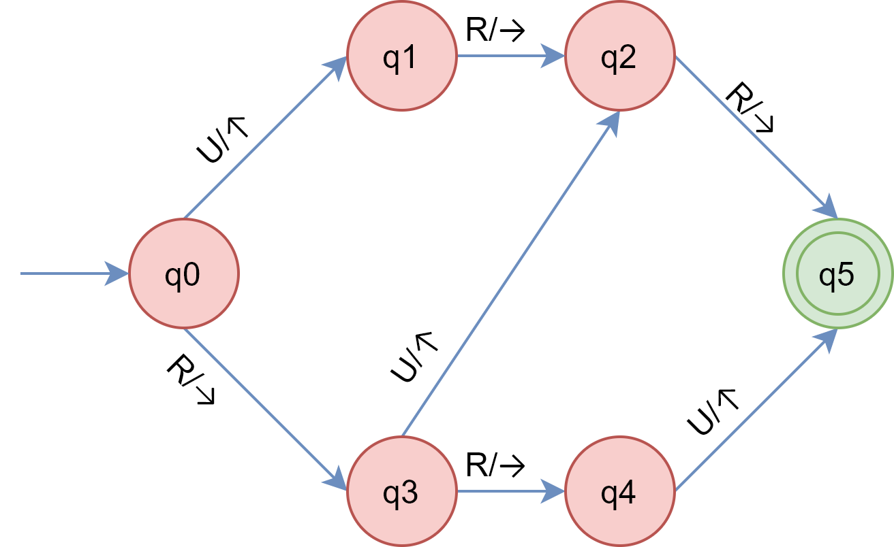

Q = {q0,q1,q2,q3,q4,q5}

**∑ = {Up, Right}** or **∑ = {U, R}** or **∑ = {↑, →}** or **∑ = {Up/U/↑, Right/R/→}**

q0 = q0

F = {q5}

**ANSWER TO THE QUESTION No. 4**

Convert the above NFA to DFA.